Mega Add-Ons sooka
1. Launch Details
Key Summary USP | sooka is a streaming service that offers live sports, local and international dramas, movies, and shows. It brings customers access to popular sports leagues like the European Premier League, La Liga, FA Cup, F1, and badminton, as well as entertainment content for all ages.  As part of the latest Mega Add-Ons launch, sooka is introduced as a new entertainment option. Customers can subscribe to the sooka streaming service through Mega Add-Ons at a special bundled monthly rate with a 12-month contract.
Channels | - CelcomDigi App  - MSA  - Pulse

2. Product Details
Offering Details:
sooka Package | Entertainment | Entertainment+ | Sports & Entertainment | Premium
Quality | HD (720p) | Full HD (1080p) | HD (720p) | Full HD (1080p)
Screens | 1 | 3 | 2 | 3
RRP (RM) | 13.90 | 28.00 | 29.60 | 44.10
CD60 SE – CD 100 | 5.90 | 15.90 | 17.90 | 34.90
CD120 & above | 1.90 | 6.90 | 8.90 | 15.90
Contract | 12 months
Internet Quota | 5GB (5G/4G)
Validity | 30days
Monthly cycle | Yes

This service is also available for subscription via StreamMORE / SpeedSTREAM.

3. Eligibility and Criteria
Eligibility & Criteria | - New subscriber (CelcomDigi Postpaid 60 SE and above)  - Existing subscriber (CelcomDigi Postpaid 60 and above)
Termination | - CelcomDigi Store only  Please inform the customer that an early termination penalty will apply. The penalty is calculated as: Recommended Retail Price (RRP) × the number of remaining contract months.

4. Customer Journey
Mega Add-ons Customer Journey | 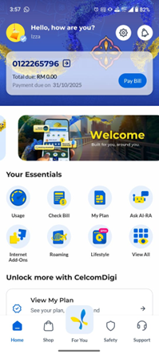 | 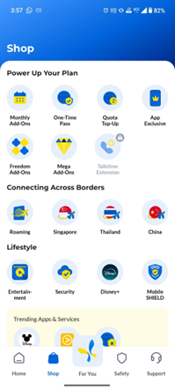 | 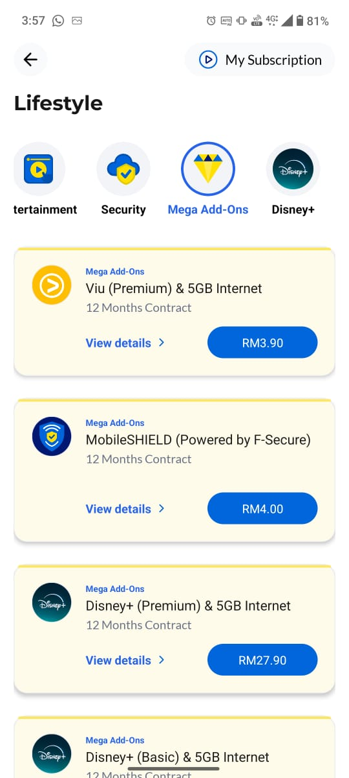
 | Step 1: In the CelcomDigi app, click Shop | Step 2: Click Mega Add-Ons | Step 3: All eligible Entertainment & Security offers will be listed here

5. Customer Communications (Active)
Active Comms | NA
FAQs | https://help.celcomdigi.com/en/support/solutions/articles/70000681965-faq-mega-add-ons-sooka-with-celcomdigi-postpaid-5g
Website | https://www.celcomdigi.com/postpaid/mega-add-ons

6. Internal Information

7. Reference Guide (Agent Guide, Scenario Handling and Other References)
Reference Guide

8. Historical Communications (no longer active but retained for reference only)
Inactive Comms | NA
Inactive Customer Journey | NA

